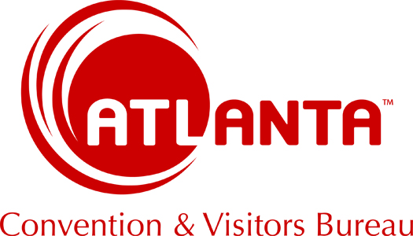

Tour Operator Request for Proposal (RFP) Form

*Note: If you require less than 10 sleeping rooms or meeting space only, please contact hotels directly with your request.

STEP 1: Provide the following information in order to receive hotel proposals. Proposals will be sent directly to you via email from interested hotels by default OR you may indicate that proposals be directed to the CVB.

STEP 2: Once you sign a contract with a hotel, please notify us via email. This may qualify you for complimentary brochures and other services.

Name of Group, School, or Club:

Name/Type of Event: (Spring Break, College Tour)

Contact Name:
Contact Mailing Address:
Contact City, St Zip:
Contact Phone:
Contact Email:

What City/State is the Group traveling from:

Total Attendance:

Proposal Due Date:
(We normally give 5 business days for hotels to respond.)

Preferred Dates:
Date Flexibility or Alternate Dates:
(Providing alternate dates or patterns may help get a better rate and avoid conventions.)

Alternate Dates:
(Providing alternate dates may help your group get a better rate and avoid other conventions. If you are not flexible at
all, please say: DATES SET)

Please specify what date will you sign a contract to secure a hotel?

Are you coming to ATLANTA for a specific event/festival?
If Yes, please list event:

Competing Cities:

Connecting Cities:
(Will you use ATLANTA to connect to another city: Birmingham, Savannah, etc.)

ROOM BLOCK (Break down by day) (Minimum of 10 rooms per night)
DAY: | Wed | Thur | Fri |  | Sat | Sun | Mon | Tues | Wed
DATE:
No. of Rooms

ADDITIONAL INFORMATION:
Sleeping Room Rate Range: (EXAMPLE: $119-139)

Areas of the city that you will consider?
OPTIONS: 1. Airport/South Atlanta 2. City Limits: Downtown, Midtown, Buckhead 3. Atlanta North Suburbs
4. If you want to be by a specific attraction say: Aquarium or Stone Mountain)

Please list any other special requests/considerations:
(Breakfast: Continental, Limited Hot, Full Hot; Pool; Baggage handling; ADA rooms, Rooms on lower level; etc.)

Anything else we should know about this group?

Please list any local attractions you are interested in receiving information from:

THANK YOU!

For full planning assistance, please visit our Travel Professionals website at:
https://discoveratlanta.com/travel-tours/

